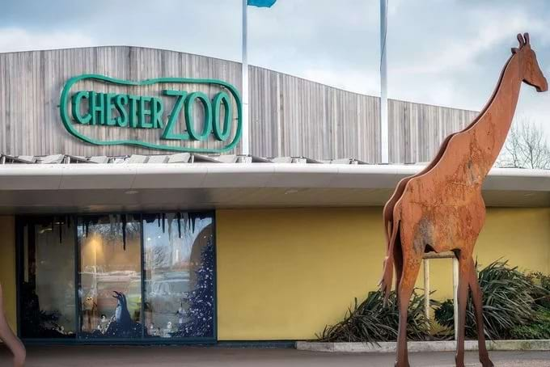

About chester zoo

What is Chester Park Zoo? and where is located established? chester Zoo, located in Upton-by-Chester, Cheshire, England, is one of the UK's largest and most visited zoological gardens. Established in 1931 by George Mottershead and his family,the zoo spans 128 acres and is home to over 27,000 animals representing more than 500 species.

Opening & Closed Timings

Chester Zoo operates year-round, opening daily from 10:00 AM Closes at 4:00 PM. Last admission is one hour before closing, with members allowed entry up to 30 minutes before closing.

The zoo is closed on Christmas Day and Boxing Day.Chester Zoo hosts various family-friendly events and educational programs throughout the year.While there are no specific "Ladies' Days," the zoo offers a Junior Programmed tailored for children aged 0-17,

including activities like Conservation Tots, Mini Rangers, Junior Rangers,

Junior Conservationists, and Young Conservationists.

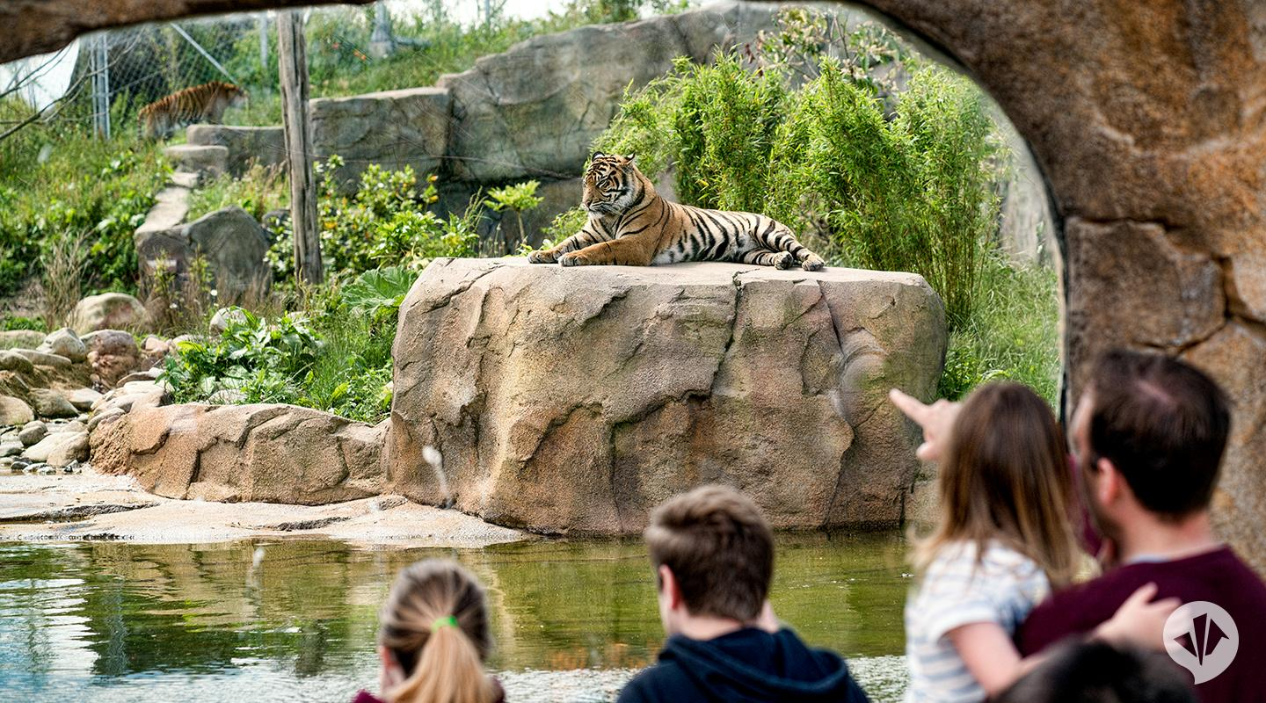

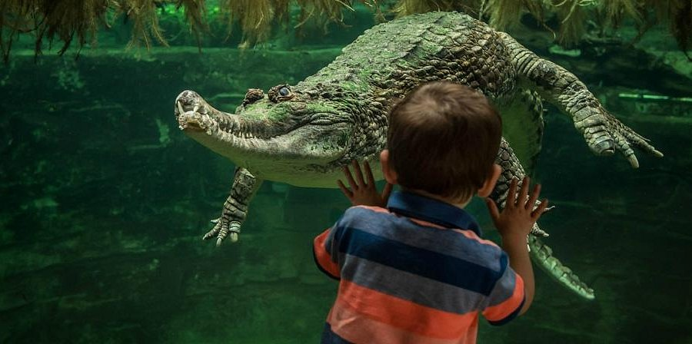

Animals List

The zoo is home to over 20,000 animals representing more than 750 Notable exhibits include:

African Painted Dog

Asian Elephant

Bornean Orangutan

Rothschild's Giraffe

Crocodile

Golden Poison Dart Frog

Komodo Dragon

Gaboon Viper

Humboldt Penguin

Address & Contact

Address:Chester Zoo, Moston Rd, Upton-by-Chester, Chester, CH2 1EU, United Kingdom.

Chester Zoo is operated by the North of England Zoological Society, a registered charity committed to conservation and education.

General Enquiries: For questions related to visiting, opening times, directions, accessibility, or other general information, you can visit their [official Chester Zoo website](https://www.chesterzoo.org/).

Email: For general inquiries, contact guest.services@chesterzoo.org.

Phone: For urgent enquiries, you can call their Supporter Contact team at +44 1244 380280.

For the most current information on events, ticket prices, and any seasonal variations in opening times, it's advisable to visit the [official Chester Zoo website](https://www.chesterzoo.org/).